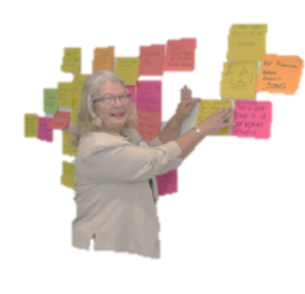

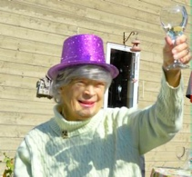
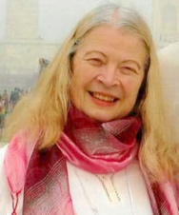

THE CAROLYN DAY AWARD FOR ENVIRONMENTAL ACTION
2021-2022

Carolyn Day, a Past-President of Ontario Council, 1998-2000, was the Environment, Clean Water and Great Lakes Policy Advisor from 2000 until her death in 2018. What started as a concern about Walkerton turned into a passion and a knowledge base. During her time, she wrote more than 40 briefs and letters, attended many meetings on our behalf and was even called by government on some occasions. This award is created in her honour.

Tell us about your work to support the environment, locally, provincially, nationally and internationally.
Please complete this Word document and email Sandy Thomson
president.cfuwontario@gmail.com copied to your Regional Director by April 15

APPLICATION FORM

Name of CFUW Ontario Club:
Number of club members & number involved in this project/activity:
Name of contact person:
Email address:
Name of project:

1. Is this project new for the 2021-2022 membership year? Yes No

2. If no, when did this project begin? (yy/mm/dd)

3. Has your club been recognized by Ontario Council for this project previously? Yes No
When? (yy/mm/dd)

4. If so, how does this project significantly build on a previous initiative?

In no more than a 1 page Word document, tell us about your environmental project and how it has made a contribution to your club and/or your members and/or CFUW and/or your community:

